PJM530

Project Schedule & Cost Control

Wiselin Mathuram

"MS Project”

Saurabh Sharma

Student ID: 143115

 05/12/2015

* Create a project for developing a website with the following phases
  + Requirements
  + Analysis
  + Development
  + Testing
* Onboard your team
  + Messi (BA) Rate 100 $/hr
  + Rocky (Dev) Rate 125 $/hr + Overtime rate 150$/hr
  + Kate (QA) Rate 80 $/hr
* Create two tasks under each phase and assign resources appropriately
  + For requirements
    - BRD Authoring (Messi – 100%) – 2 weeks
    - BRD Review (Messi – 50%, Rocky 50%) – 3 days
  + Analysis
    - FSD authoring (Messi – 100%) – 2 weeks
    - FSD Review (Messi – 50%, Rocky 50%) – 5 days
  + Development
    - Developing the website (Rocky 100%, Messi 25%) – 5 weeks
    - Unit Testing (Rocky 100%, Messi 25%) – 2 weeks
  + Testing
    - Test case authoring (Kate 100%) – 1 week
    - Test case execution (Kate 75%, Messi 25%, Rocky 75%) – 4 weeks
* Dependencies
  + BRD Review can start half way when Authoring is done
  + FSD Authoring can start in paralles to BRD review
  + Development has to start after analysis is completed
  + Test case authoring can start after BRD review is completed
  + Test case execution has to start after unit testing is completed

Demonstrate the following

1. Develop the project schedule showing dependencies
2. Gantt Chart

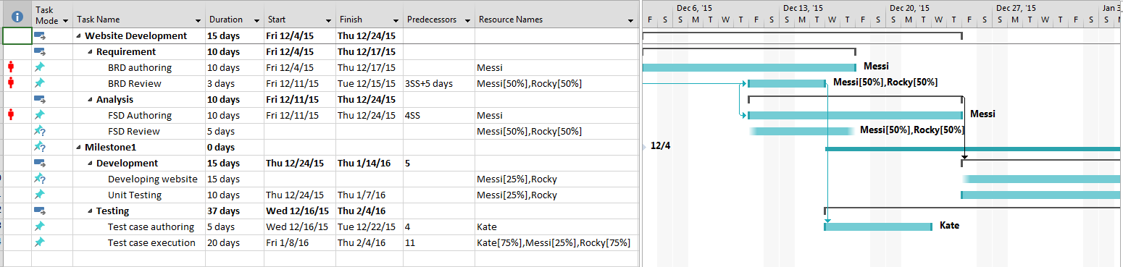

1. Critical path

On Gnatt chart, click “Task Name” --- filter --- critical

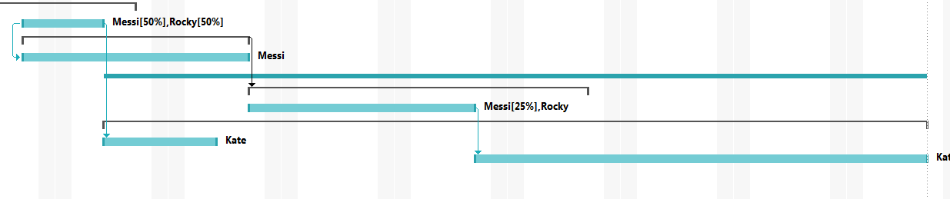

1. Resource Leveling

Click “Resoucre”, select “Level Resource” and select the resource to level

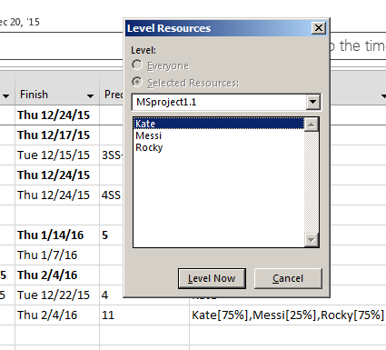

1. Setting project baseline Click “Project” and select “Set Baseline”

There can be multiple baselines set by overriding the original one if it exists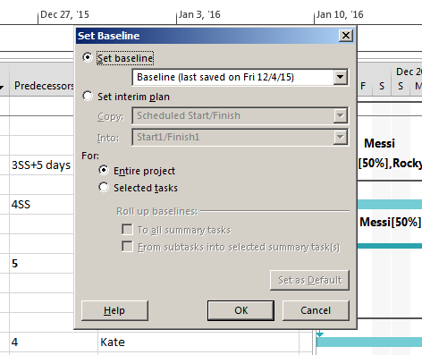

1. Earned value cost indicators (First project has to be baselined and some tasks be completed some percent )

Click “view --- table --- more tables --- select

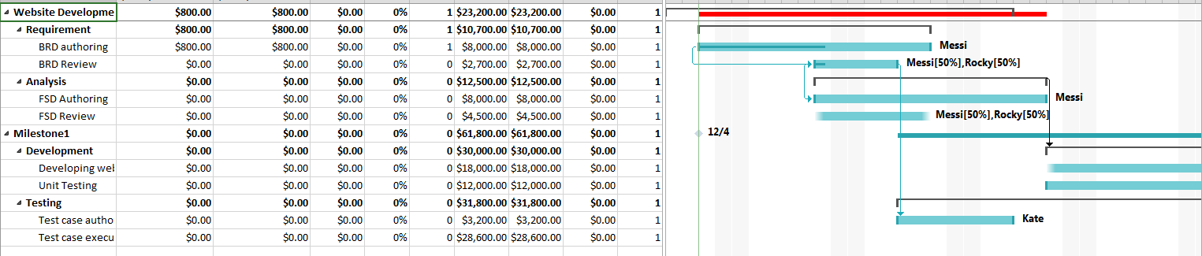

1. Earned value schedule indicators (same as above, but select EV schedule)

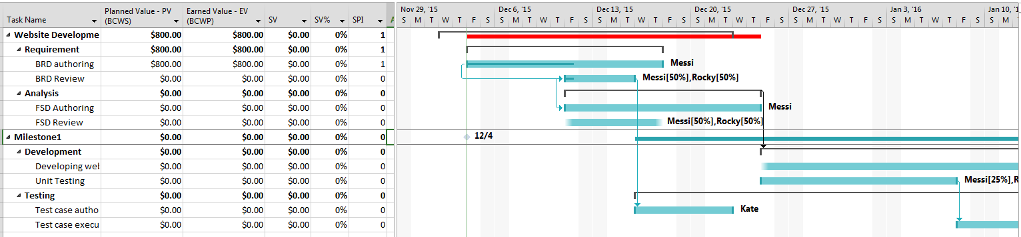

1. Showing slack in the Gantt chart

On the View menu, click More Views.

In the Views list, click Detail Gantt, and then click Apply.

On the View menu, point to Table, and then click Schedule.

In the chart portion of the view, slack appears as thin bars to the right of tasks, with slack values adjoining the regular Gantt bars.

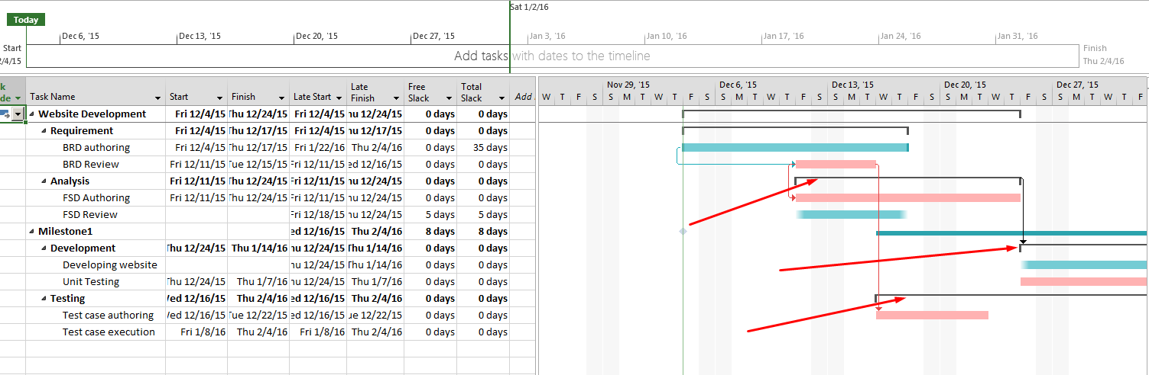

1. Add a milestone :Create a task with 0 duration

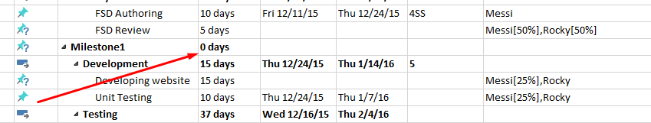

1. Demonstrate a custom report to show resource usage (optional) (View --- Resource usage)

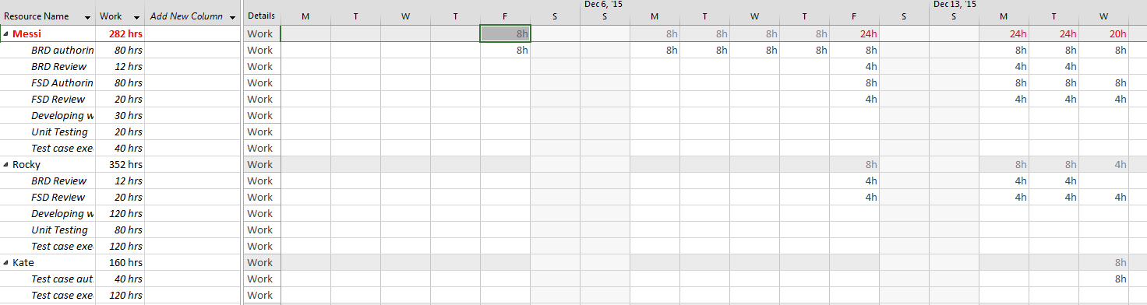

1. Timeline to copy into a presentation

Click on timeline ---- right click --- copy timeline for presentation

Start  
Fri 12/4/15

Finish  
Thu 2/4/16

Dec 6, '15

Dec 13, '15

Dec 20, '15

Dec 27, '15

Jan 3, '16

Jan 10, '16

Jan 17, '16

Jan 24, '16

Jan 31, '16

**Today**

1. Calculate Budget

View --- tables --- more tables --- costs

It shows the actual and the estimated budget

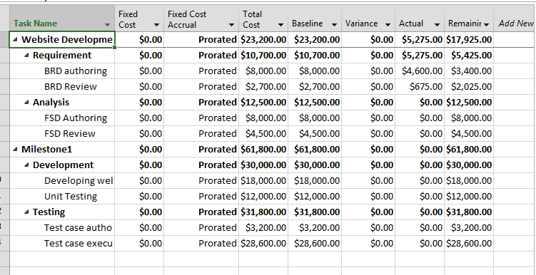

Report --- cost --- more report --- costs --- task cost overview

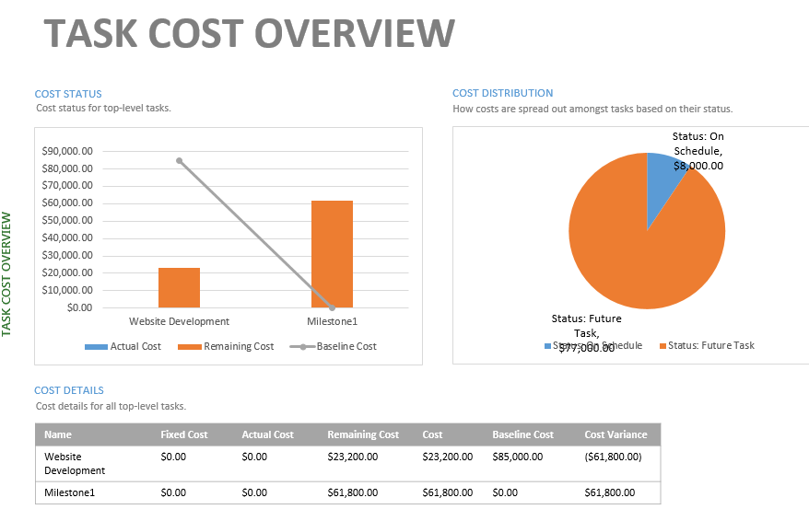

Final After implementing all tables and fields

